

**CSE 460: Software Analysis and Design**

**Directory Management System Phase I Submission**



**Directions:**

Complete your work for Phase I Parts 1 and 2 in this document. Save and submit as a **single**​PDF titled “Last Name_First Name_Directory Management SystemProject_Phase I_Submission”.

**Directory Management System Project Submission**



**Phase I, Part 1**

Use the Astah tool to draw the class diagram for the current implementation of the university system. Use correct UML notations. When you have completed the diagram, take a clear screenshot and paste it in the space provided.

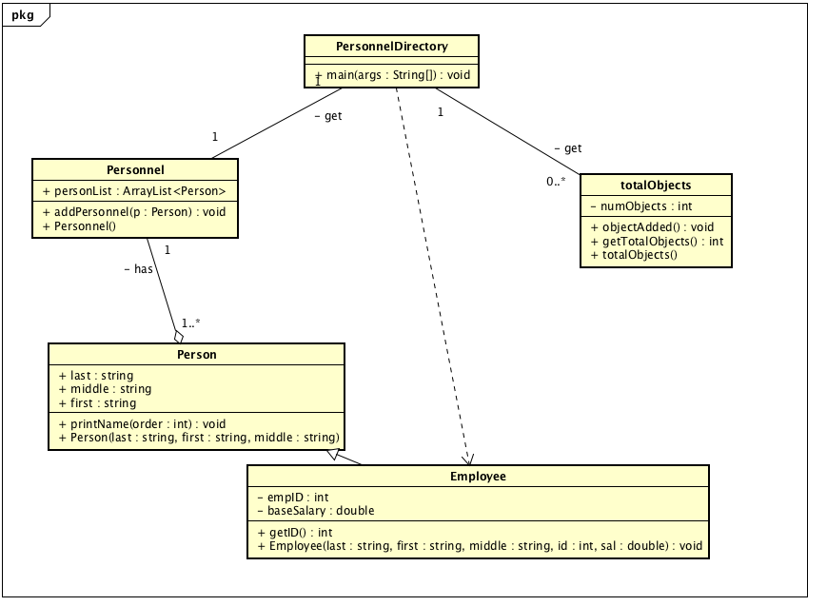

**Directory Management System Project Submission**



**Phase I, Part 2**

In the code, identify object-oriented concept violations, content coupling, common coupling, control coupling and stamp coupling situations. Copy and paste the code segments that shows each coupling situation in the space provided. ​*You may use* *additional space as necessary.*

1. **Object-Oriented Concept Violations**

[paste code segments here]

**public** **class** Person {

**public** String last;

**public** String first;

**public** String middle;

**public** ArrayList<Person> personList;

These violate Encapsulation concepts.

**public** **class** totalObjects

{

**private** **static** **int** *numObjects* = 0;

**public** totalObjects()

{

*numObjects*=0;

}

**public** **void** objectAdded()

{

*numObjects*++;

}

**public** **int** getTotalObjects()

{

**return** *numObjects*;

}

}

**public** **int** getID()

{

**return** empID;

}

These are Data Abstraction violations.

**How would you fix these violations?**

I would fix the Encapsulation violations by making the public variables in the Person class and Personnel class private. For the Data Abstraction violations I would remove the totalObjects class and just use a personList.size() in a method to get the total number of objects and I would remove the getID() method because it is never used.

1. **Content Coupling**

[paste code segments here]

**boolean** found = **false**;

**int** loc =-1;

**for**(**int** i =0; i <per.personList.size(); i++)

{

**if**( per.personList.get(i).first.equals(firstN) && per.personList.get(i).last.equals(lastN))

{

found = **true**;

loc = i;

}

}

**if**(found)

{

System.***out***.println("Found");

per.personList.get(loc).printName(0);

}**else**

{

System.***out***.println("not found");

Person p1 = **new** Person(lastN, firstN, " ");

per.personList.add(p1);

total.objectAdded();

}

**How would you fix this?**

I would fix this by calling addPersonnel and not per.personList.add to reduce the coupling and that the PersonnelDirectory is more interested in the responsibilities of the interface.

1. **Common Coupling**

[paste code segments here]

**private** **static** **int** *numObjects* = 0;

**else**

{

System.***out***.println("not found");

Person p1 = **new** Person(lastN, firstN, " ");

per.personList.add(p1);

total.objectAdded();

}

**How would you fix this?**

[Write your answer in this space.]

Having a static variable is like having a global variable and by removing this and the totalObject class I can fix the common coupling error that could happen with this variable and the PersonnelDirectory class is modifiying the public personList from Personnel class so I would move this into the Personnel class to reduce coupling.

1. **Control Coupling**

[paste code segments here]

**public** **void** printName(**int** order)

{

**if**(order == 0)

{

System.***out***.println(first + " " + middle + " " + last);

}**else** **if**(order == 1)

{

System.***out***.println(last + " ," + middle + " " + first);

}

**else** **if**(order == 2)

{

System.***out***.println(last + " ," + first + " " + middle);

}

}

System.***out***.println("Enter the order 0: first, middle, last, 1: first, last, middle, 2: last, first , middle ");

**int** order = scan.nextInt();

**for**(**int** i=0; i<per.personList.size(); i++)

{

per.personList.get(i).printName(order);

}

**How would you fix this?**

[Write your answer in this space.]

I would fix this by creating three different print functions in the Person class so that it does not rely on the int order as a control parameter from PersonnelDirectory class.

1. **Stamp Coupling**

[paste code segments here]

public void addPersonnel(Person p)

{

personList.add(p);

}